Office of the Principal

TENGAKHAT COLLEGE
Estd. 1967
UGC affiliated 2 (F) and 12 (B) 2007
NAAC Accreditated Grade “B⁺⁺”
P.O. TENGAKHAT, DIST. DIBRUGARH, PIN-786103 (ASSAM)
Website: http://www.tengakhatcollege.in
E-mail: tengcoll103@gmail.com
NýáÛÚ 22-06-2023
GáRRã
bÙÿZá\ k‡á\á íýIýDüáAáNý XbáâUPóá]Z\ KÙýfEýNý\ XáQóâX@ü S÷OX Uáâ_Þ@üNý RáXWýâNÞý\ UáïíU #áíUPR @ü\á ýFýá¼-ýFýá¼ãa@ü]@ü GïíRáVá bZ íY XbáâUPóá]Z\ KÙýfEýNý\ XáQóâX@ü\ RáX WýâNÞý 26 GåR, 2023 Nýáâ\A íaáXUáïí\ âPR\ 10.30 UGá\ S\á #RåâÌýNý b’Uñ ýFýá¼-ýFýá¼ãa@ü]@ü bábÙÿy€åý] â^¤üáÿw‚ S\ã¤üá\ KÙýºýãMÞ\ S÷XáR S¼, Rx‡\ Nýáâ]@üá #á\ë Uáâ_Þ@ü #áZ\ S÷XáM S¼ ]BNý #áâRU\ UáïíU GïíRáVá b’]ñ
RáXWýâNÞý\ Nýáâ\A
y‡á¤ü\
26 GåR, 2023 #Qó¤ü
âPR\ 10.30 UGá\ S\á ïíýIýDüáAáNý XbáâUPóá]Z
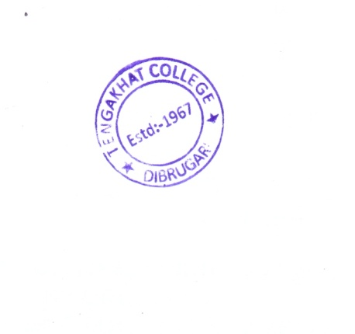
íýIýDüáAáNý

